

Global Broadband Quality Study Shows Progress, Highlights Broadband Quality Gap

Broadband quality improves around the world despite economic downturn

LONDON, October 1, 2009 - The results of the second annual global study on the quality of broadband connections released today reveal that 62 out of the 66 countries analyzed had improved the quality of consumer broadband services since last year. However, new data from the study highlights the extent of the digital quality divide between urban and rural areas and, for the first time, compares the quality of fixed and mobile broadband services.

The first groundbreaking Broadband Quality Study was published in September 2008 to highlight each country’s ability to benefit from next-generation web applications and services. The research team found that broadband quality is linked to a nation’s advancement as a knowledge economy and countries with broadband on their national agenda had the highest broadband quality. This year’s report covers an additional 24 countries and includes new analysis on broadband quality in more than 240 cities.

The 2009 research delivers new insight into who the global broadband leaders are by combining data for each country’s broadband penetration with a measure of the quality of broadband services actually experienced by its citizens. The study was conducted by a team of MBA students from the Saïd Business School at the University of Oxford and the University of Oviedo’s Department of Applied Economics, and sponsored by Cisco.

Highlights / Key Facts:

- Overall average broadband quality increased across the globe:
  - Global average download throughput increased by 49% to 4.75 Megabits per second (Mbps)
  - Global average upload throughput increased by 69% to 1.3 Mbps
  - Global average latency decreased by 21% to 170 milliseconds
- South Korea tops the 2009 Broadband Leadership table.

 |  | Broadband Penetration (% of households) | Broadband Quality Score 2009 | Broadband Leadership 2009
1 | South Korea | 97% | 66 | 139
2 | Japan | 64% | 64 | 115
3 | Hong Kong | 99% | 33 | 111
4 | Sweden | 69% | 57 | 110
5 | Switzerland | 90% | 40 | 108
6 | Netherlands | 83% | 46 | 108
7 | Singapore | 96% | 32 | 107
8 | Luxembourg | 99% | 27 | 107
9 | Denmark | 82% | 45 | 106
10 | Norway | 84% | 38 | 102

- South Korea rose just above last year's broadband quality leader Japan with a 72% improvement in its Broadband Quality Score (BQS). This improvement has been driven by continuous efforts by the government to strengthen the country’s position as one of the world’s ICT leaders. Combined with higher broadband penetration, South Korea rises above Japan in the global Broadband Leadership rankings.
- Japan stands out as having the cities with the highest BQS in the world, with Yokohama and Nagoya leading the BQS rankings and Sapporo not far behind.
- Sweden has the highest quality broadband in Europe. It is rapidly catching up with Japan and South Korea as its BQS improves 38% from 2008. Sweden is the most successful country in closing the broadband quality gap with residents outside the most populated cities enjoying better quality than those in the cities.
- Lithuania, Bulgaria and Latvia come just behind Sweden in quality boosted by recent city-based fibre rollouts and cable improvements but low broadband penetration means these countries have yet to break into the broadband leaders’ category.
- 39 countries have a BQS above the threshold required to deliver a consistent quality of experience for the most common web applications today, such as social networking, streaming low-definition video, web communications and sharing small files such as photos and music.
- Nine countries, South Korea, Japan, Sweden, Lithuania, Bulgaria, Latvia, The Netherlands, Denmark and Romania, were found to have the broadband quality required for future web applications, such as high definition Internet TV viewing and high-quality video communications (such as home telepresence) that will become mainstream in the next 3 to 5 years. In 2008, only Japan exceeded this threshold.
- The research compares countries according to their stage of economic development:
  - Amongst the developed, innovation-driven economies, South Korea achieved the greatest improvement in broadband quality over the past year with a 73% increase in BQS. Sweden, the USA and the Czech Republic also saw significant above average improvements.
  - Amongst efficiency-driven economies, Bulgaria topped the most improved list with a 57% increase in BQS from 2009. Lithuania, Romania and Latvia also achieved above average improvements.
  - Amongst factor-driven economies, Kenya actually trebled its BQS but the overall score for Kenya remains well below the threshold required for today’s applications. Vietnam and Qatar followed Kenya as having made the most progress in broadband quality for countries in this stage of economic development.
- The cities with the highest BQS of all the countries in the study were:

Top 10 Cities | BQS | Next 10 Cities | BQS
Yokohama, Japan | 85 | Rotterdam, The Netherlands | 55
Nagoya, Japan | 82 | Riga, Latvia | 54
Kaunas, Lithuania | 79 | Copenhagen, Denmark | 53
Sapporo, Japan | 72 | Bucharest, Romania | 52
Seoul, South Korea | 68 | Stockholm, Sweden | 51
Malmo, Sweden | 67 | Vilnius, Lithuania | 50
Osaka, Japan | 65 | Zurich, Switzerland | 49
Wuhan, China | 60 | Tokyo, Japan | 49
Uppsala, Sweden | 57 | Goteborg, Sweden | 49
Sofia, Bulgaria | 56 | Kosice, Slovakia | 48

- The research team compared the difference between the BQS in the most populated cities with the BQS in the rest of the country. Although a digital quality divide was found in the majority of countries, 13 countries showed significant differences in BQS between its major cities and the rest of the country. Lithuania, Russia and Latvia had the biggest digital quality divide, while rural residents in Sweden, United Arab Emirates and Iceland enjoyed similar, if not slightly higher quality broadband services than their city counterparts.
- The country with the highest broadband quality outside of its major cities was Japan, followed by Korea and Sweden.
- The study also included data on the quality of mobile broadband services for the first time. On average, mobile devices connecting to WiFi services meet the broadband quality threshold required for today’s mobile Internet applications. The average BQS of 3G and 3G+ technologies do not currently meet the threshold due to low upload throughput.

Quotes:

- Alastair Nicholson, Associate Fellow, Saïd Business School, University of Oxford
“The Broadband Quality Study in 2008 helped to establish a better understanding of the driving factors and the socio-economic impact of broadband quality. New web applications will continue to increase demand for improvements in the key performance parameters of download and upload throughput and latency that we use to calculate broadband quality. This year, by comparing the broadband quality of countries in the same stage of economic development, we have a view of which countries are over-achieving for their stage of development. I am delighted that two of our MBA students could participate in the research project and have made such a useful contribution to our understanding of broadband quality internationally.”

- Professor María Rosalía Vicente, University of Oviedo
“The Broadband Quality Study shows us which countries have made real moves towards the Internet of the future. It also provides fresh evidence of the urban versus rural quality divide. The challenge for countries now is to bridge this quality divide.

This quality divide could indicate how future divides in wealth may take shape, as broadband is increasingly determining the ability of individuals, firms and nations to create future prosperity.”

- Fernando Gil de Bernabé, senior director, Cisco
“Ever since we embarked on the first Broadband Quality Study with Saïd Business School MBA students and the University of Oviedo we were looking forward to seeing what this year’s results would reveal. We certainly haven’t been disappointed. It is really exciting to discover that almost every country has seen improvements in broadband quality, despite the economic turmoil of the past year. We can actually see how countries that have made significant investments in fibre and next-generation cable technologies including Korea and the United States, are seeing real progress in broadband quality.

This study has put quality onto the broadband agendas of every country that is aspiring to become a broadband leader. Having real data on broadband quality and tying it together with social and economic factors is helping Cisco shape the conversations we are having with governments, policy makers and regulators around the world.”

Links / URLs:

- Broadband Quality Study 2009 – Report
Add link

- Broadband Quality Study 2008
http://www.sbs.ox.ac.uk/news/media/Press+Releases/New+High-Quality+Broadband+Study.htm

Charts:

Broadband Leadership Matrix – top 20 countries

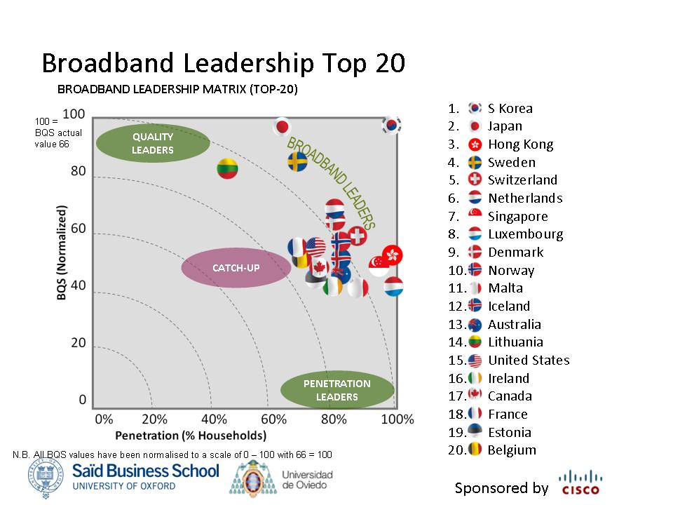

Broadband Leadership Matrix – second 20 countries

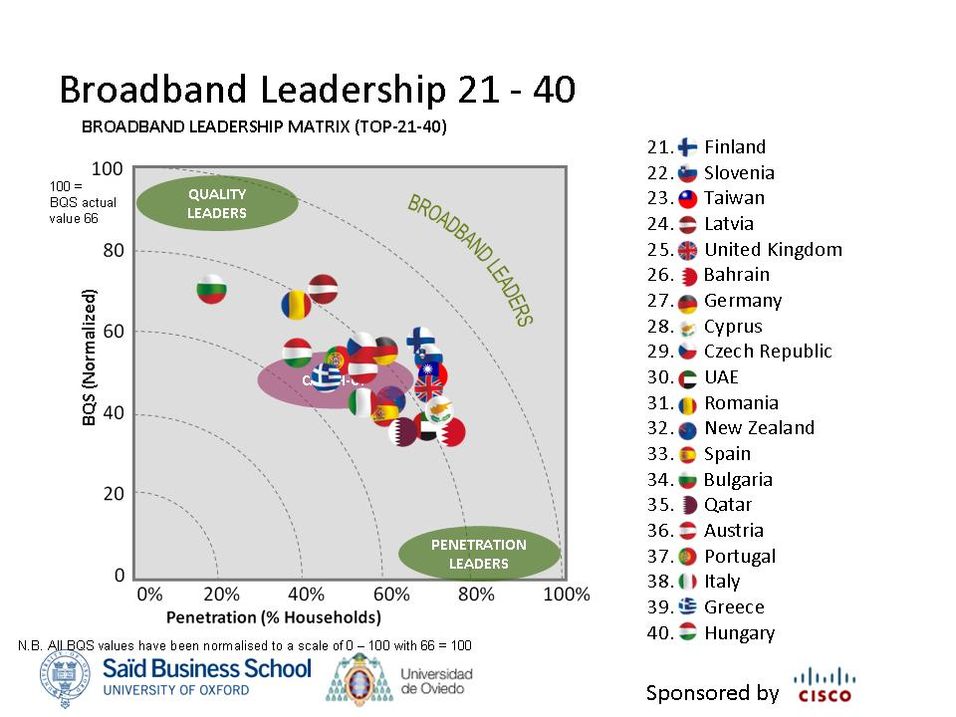

Broadband Leadership Matrix – final 26 countries

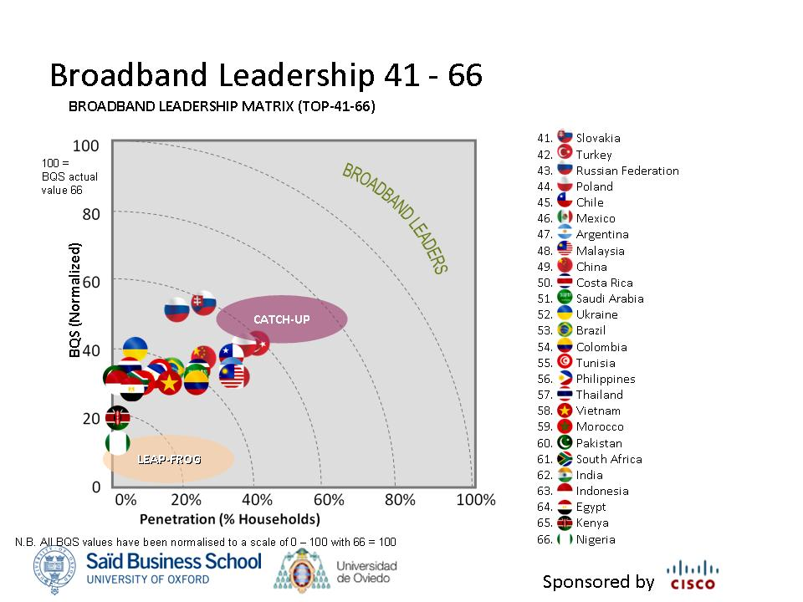

Broadband Quality Gap between cities and rural areas

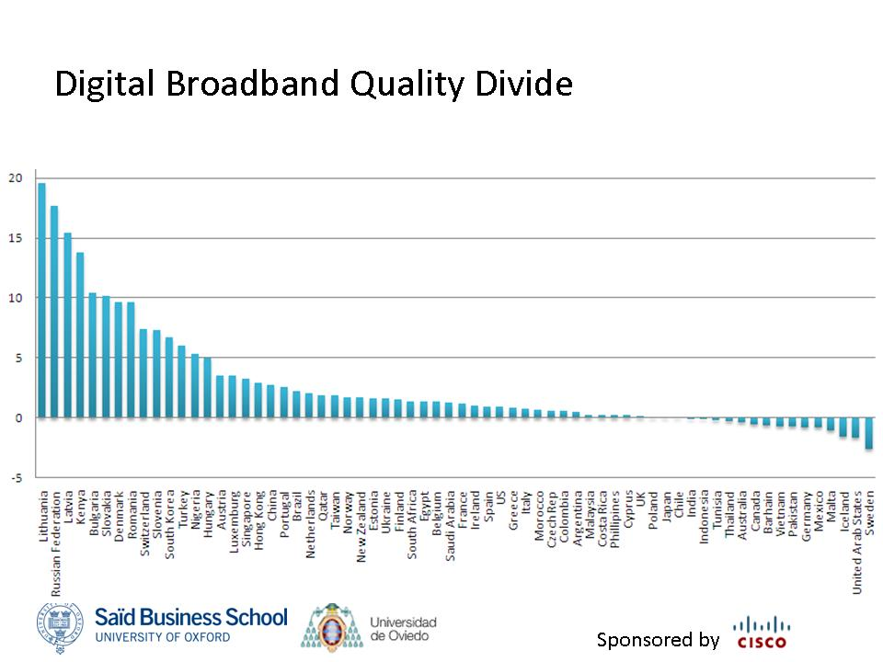
Notes for Editors:
Using more than 24 million records from actual broadband speed tests conducted by users around the world in May 2008 and from May to July 2009 through www.speedtest.net, the research team calculated statistical averages for each country of several key performance parameters used to determine the quality of a broadband connection. The team concluded that broadband experience is mainly affected by broadband speeds in both directions, latency, network oversubscription, and packet loss. These parameters were grouped into three major categories: download and upload throughput, and latency. The Broadband Quality Score (BQS) for each country was determined using a formula that weighted each category according to the quality requirements of a set of popular applications now and in the future. Typical applications for today include web browsing, social networking, music downloads, basic video streaming and video chatting, standard definition IPTV, and enterprise-class home offices. Future applications include consumer telepresence for communications, healthcare and education, high-quality video file sharing and streaming, high-definition IPTV, cinema-quality live event broadcasts and advanced home automation.

The Research Team
Saïd Business School, University of Oxford
Weigang Fu, MBA student 2008-2009
Sudeep Jain, MBA student 2008-2009

University of Oviedo
Prof María Rosalía Vicente

About the Saïd Business School, University of Oxford
Established in 1996 the Saïd Business School is one of Europe’s youngest and most entrepreneurial business schools with a reputation for innovative business education. An integral part of Oxford University, the School embodies the academic rigour and forward thinking that has made Oxford a world leader in education. The School has an established reputation for research in a wide range of areas, including finance and accounting, organisational analysis, international management, strategy and operations management. The School is dedicated to developing a new generation of business leaders and entrepreneurs and conducting research not only into the nature of business, but the connections between business and the wider world. It is ranked in the top 20 European Business Schools (Dec 08) and in the top 20 MBA programmes in the world (Jan 09) by the Financial Times. It is ranked in BusinessWeek’s top 10 business schools outside the USA (Nov 08). In the Wall Street Journal it is ranked in the top 25 business schools in the world (Nov 07). In the UK university league tables it has ranked first of all UK universities for undergraduate business for the past six years in The Guardian and in seven of the last eight years in The Times. For more information, see www.sbs.ox.ac.uk/

# # #

Press Contacts:
Clare Fisher  Head of Public Relations,  Saïd Business School  Direct telephone: +44 (0) 1865 422713  Email: clare.fisher@sbs.ox.ac.uk  Josie Powell, Public Relations Coordinator  Direct telephone: +44 (0) 1865 422573  Email: josie.powell@sbs.ox.ac.uk or pressoffice@sbs.ox.ac.uk | For Cisco  George Wright  Brands2Life  Tel: +44 207 592 1200  Email: george.wright@brands2life.com

Stages of Economic Development as defined in the World Economic Forum Global Competitiveness Report. http://www.weforum.org/pdf/GCR09/GCR20092010fullreport.pdf

